Scalar Subquery in SELECT

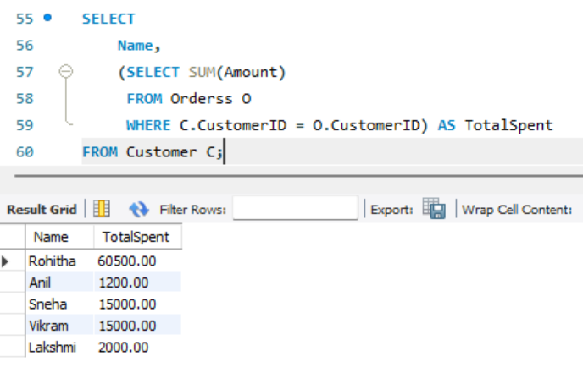

Subquery in WHERE with IN

Subquery in WHERE with EXISTS

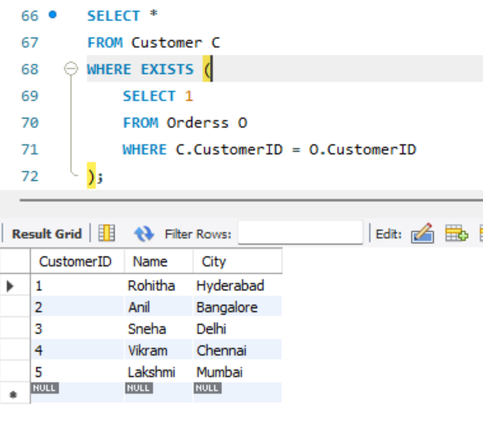

Subquery in FROM Clause

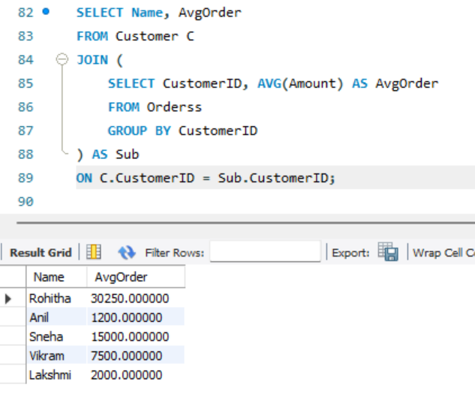

Top Spender Using Subquery and ORDER

